**How to install Scilab6.10 in Microsoft Window 10**

1. Run “scilab6.10.exe” file. And Select the language to be used during the installation process.

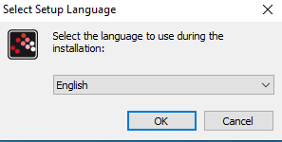

1. After you read the License Agreement and if you agree to the terms, select “I accept the agreement” and click on the “Next” button.

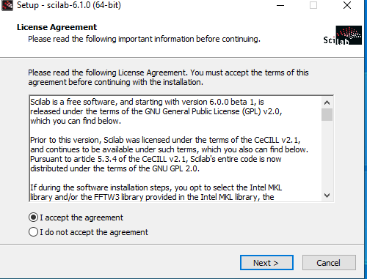

1. First make sure that you have enough disk space for scilab installation. On the bottom of the screen there is a message informing you the minim free space required for the software.

Choose in which folder on your computer Scilab will be installed. You can leave the default path.

Click on the “Next” button.

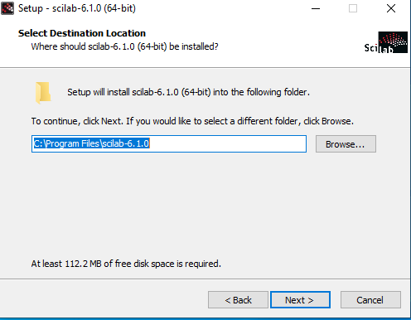

1. You can choose what software modules you want to install with Scilab. From the drop-down menu you can choose the type of installation. “Full Installation” will install the complete/full package of components/modules.

Be aware that the “Full Installation” type will require 500 MB of free disk space.

You can see some details about the installed modules/components by clicking on the “About modules” button.

After you Selection, click on the “Next” button.

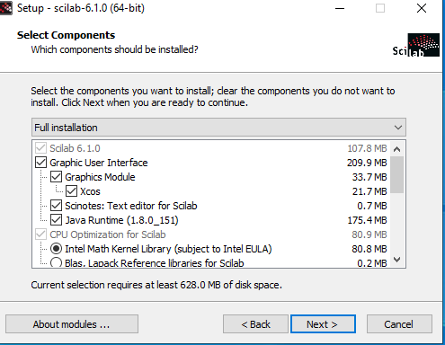

1. You can choose the Start menu folder for the installation. If you want a different location than the default one. Click the “Browse” button.

After you made your choice, click on the “Next” button.

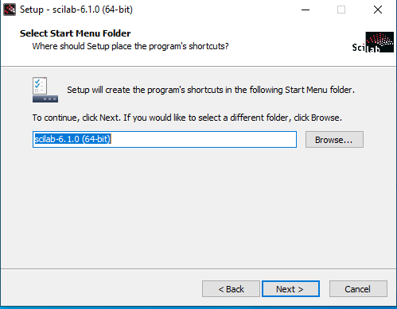

1. If you want to create a Desktop icon make sure to check the box for “Create a desktop icon”

Check all five boxes for file association this way you’ll associate *.sce, *.sci, *.tst, *.xcos, *.cos and *.cosf, *.zcos, *.sod files with scilab.

Click on the “Next” button to continue.

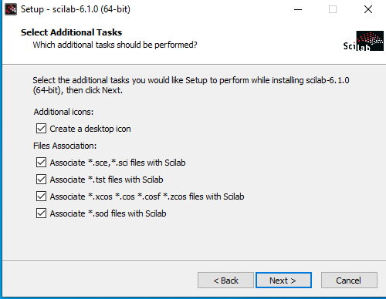

1. Before the installation starts you’ll see a summery window with the installation settings. If something is not as expected use the “Back” button to get to the desired menu to perform change.

If all settings are as expected, click the “Install” button.

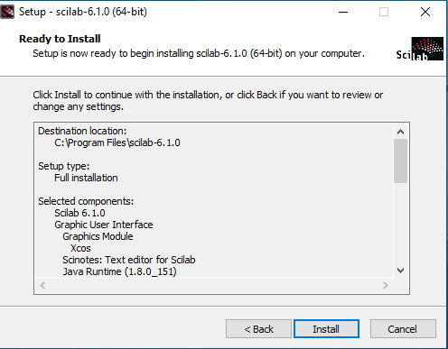

1. Depending on the performance of you computer (CPU, RAM, HDD) the installation time will vary. If you want to abort installation click the “Cancel” button. Otherwise wait until the progress bar fill up.

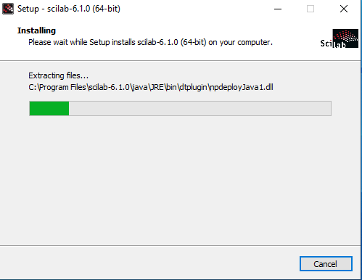

1. At this point the installation is finish, Scilab is installed on you computer. If you check the box for “Launch Scilab”, when you click the “Finish” button, Scilab will be launched.

Click the “Finish” button to exit the Setup Wizard.

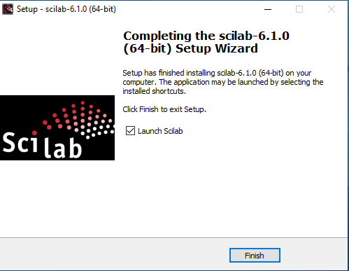

1. Launch Scilab.

